Data Structures in Eclipse Dirigible
Follow the steps to create a Data Structure in Eclipse Dirigible:
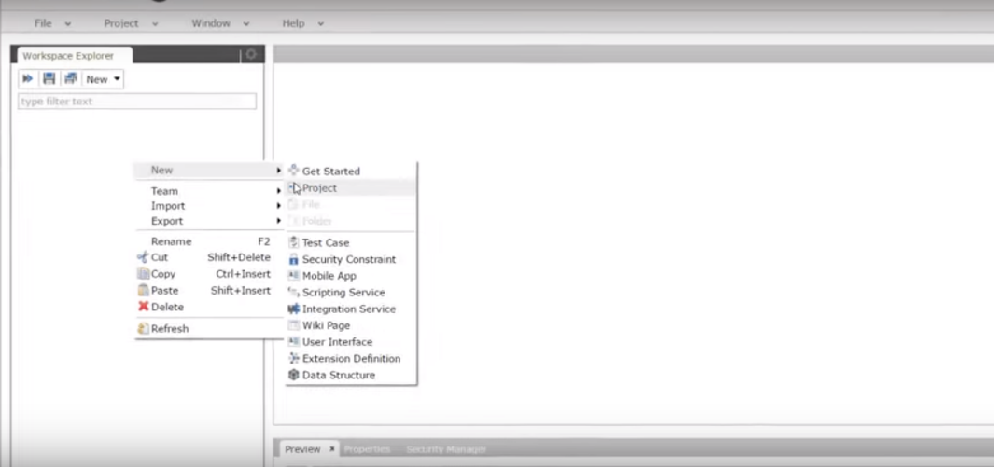
- Click with the right button on the workspace explorer on the left and choose NEW, from the dropdown menu select PROJECT.
Afterwards you need to enter an appropriate name for the project and click on the NEXT.

- You can select one of the predefined project templates, but for now you need to select BLANK APPLICATION, then click FINISH.

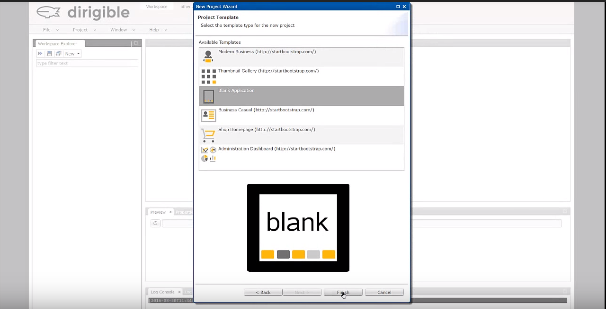

- Now on the left in the Workspace Explorer your project is created.
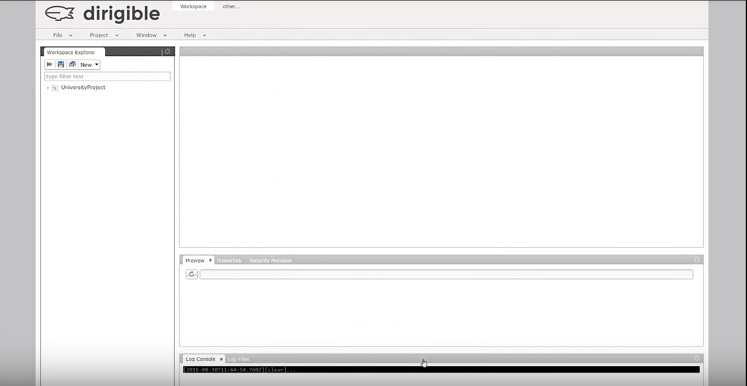
- Now click with the right button on the project name and from the dropdown menu choose DATA STRUCTURE. Select and create a RELATIONAL DATABASE TABLE, then click NEXT.
- Now add all necessary table properties, with clicking ADD you are creating different columns.
- Define an ID attribute as a primary key.
(write “ID” for the column NAME, select “Integer” for the TYPE, do not select any of the boxes “NOT NULL?” and “PRIMARY KEY?”, click OK)
- Add 2nd column with attributes.
(write “FIRST_NAME” for the column NAME, select “Varchar” for the TYPE, for LENGTH enter “30”, select “NOT NULL?” and OK)
- Add 3th column with attributes.
(write “LAST_NAME” for NAME, the TYPE is “Varchar”, LENGTH – “30”, select “NOT NULL?” and OK)
- Add 4th column with attributes.
(“AVERAGE_GRADE” for the column NAME, the TYPE is “Double”, select “NOT NULL?” and OK)
- Add 5th column with attributes.
(write “BIRTH_DATE” for the column NAME, the TYPE is “Date”, select “NOT NULL?” and OK)
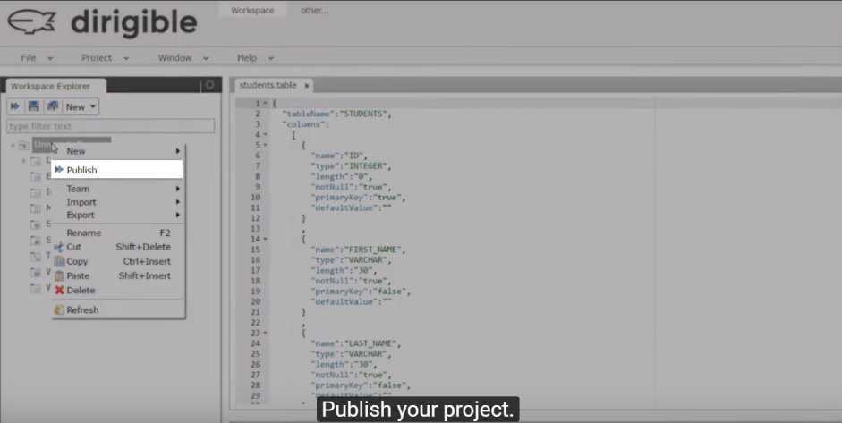
- Name your table, you can name it with “students”.

7) Publish your project by clicking with the right button on the project name and from the dropdown menu choose PUBLISH.

8) Open the database view by clicking on the top of the program OTHER…, then choose the option DATABASE, then select OK.

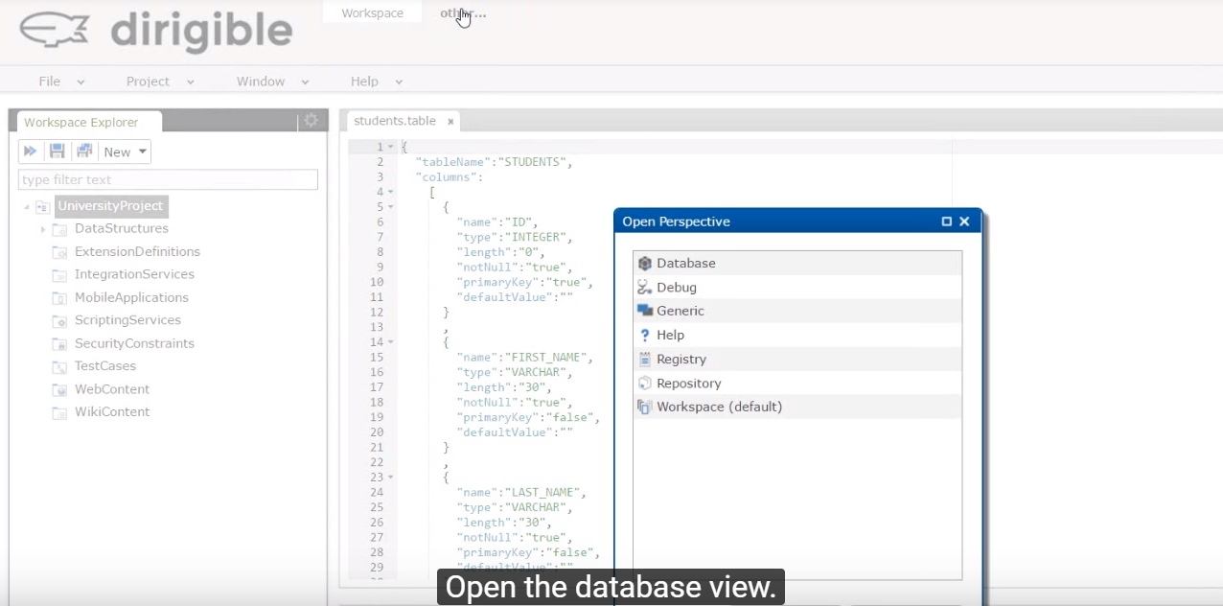

9) In the SQL Console window type SELECT*FROM command and the name of the table.
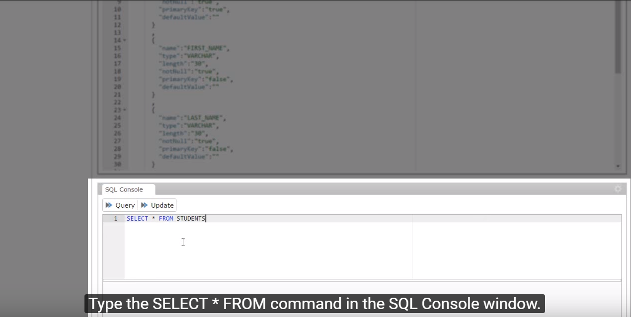

10) Click on Query if nothing shows up, another DATA STRUCTURE should be implemented.

11) Add new data structure, select the Delimiter Separated Values (DSV) TEMPLATE and choose NEXT.
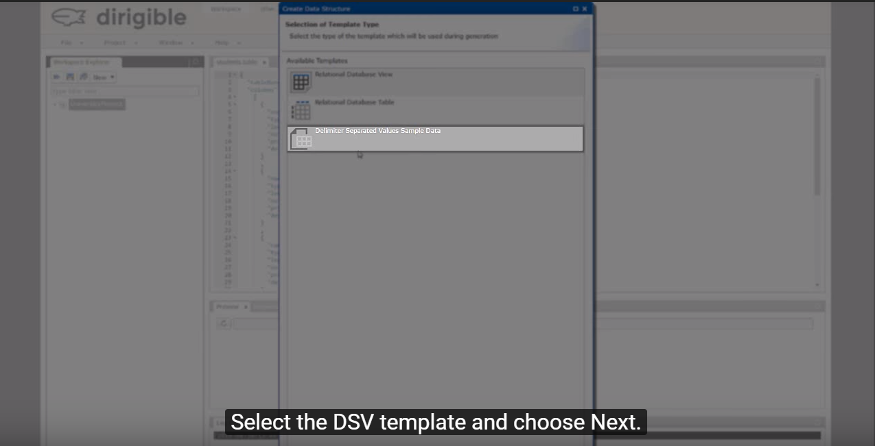

12) Find your table and select it, click NEXT, click FINISH. Publish your project again, with the previous instructions for publishing.
13) Open the database view. Type SELECT*FROM command and the name of the table in the SQL Console window, click QUERY, the publishing will be successful.

